**CS 1371 Project Homework: Using Microsoft Excel**

Contents

Introduction 1

Part 1 – Basic Excel Knowledge (Store Price Calculator) 1

Part 2 – Using Functions (Grade Calculator) 4

Part 3 – Conditionals (GPA Calculator) 5

Part 4 – Advanced Excel Usage (Sign-Up Sheet) 7

Part 5 – Graphs 8

Extra Information – OPTIONAL (Not Graded) 9

Reference Pictures 11

# 

# Introduction

**What is Microsoft Excel?**

Microsoft Excel is a spreadsheet application. Spreadsheets serve as efficient ways to organize data by grouping it into rows and columns. As a promising Tech student, you may never need to look at Excel after this project. However, if one finds the need to organize numbers in a computer or perform administrative chores, Excel may soon become the best seven million lines of code ever written. Please note: this project assumes you will be working with Microsoft Excel 2007 or higher. This means that you should turn in a *.xlsx file. If you do not have Excel 2007 or higher, you can either use a school computer, or you can download a free copy of Microsoft Office 365 through Georgia Tech. For more information check out the [OIT Website](https://faq.oit.gatech.edu/content/im-student-how-can-i-get-access-microsoft-office-365-pro-plus-free).

**Vocabulary**

*Cell –* the small boxes where data exists in a spreadsheet

*Range* – a collection of cells

*Sheet –* specific “page” of the Excel file. You can switch between sheets using the ribbon at the bottom of the screen

*Function –* with your extensive knowledge, no definition is necessary

*Formula –* the combination of functions and operations inside of a cell. A formula always begins with an equals sign (“=”)

# Part 1 – Basic Excel Knowledge (Store Price Calculator)

Retrieve the assignment (“Excel_Project.xlsx”) from the project folder.

Each cell in the Excel spreadsheet has a unique identifier, much like the index of an element in an array. Note that the first column in the spreadsheet is labeled A, and the first row is labeled 1. Like arrays in MATLAB, spreadsheets use a coordinate-like system to access elements. Unlike in MATLAB, letters are used to refer to columns. For example the top-left cell in the spreadsheet is called “A1”.

In this part of the lab, you are working for a convenience store and are in charge of ordering new products and submitting a budget to your supervisor. You will use Excel to help with the calculations.

**Resizing and Selecting Columns / Rows**

When you first open the spreadsheet, you will notice that some of the data is hidden because it is too large for the cell. (Take a look at cell C1 or A26 if you are confused – part of the header is missing because there is not enough room to display all of the text). We can fix this by resizing the columns so all of the data fits in one cell. To do this, hover over one of the two edges of the column letter at the top of the sheet. You will see your curser change to the one in the picture below. Once your curser changes, click and drag the column to the correct size.

1. ***Resize columns A, C, E, and F such that you can see all of the text (both in the headers and in the below columns) NOTE: The specific adjustment is not important, just enough that you can see all of the text.***

To select an entire column or row, simply click on the row or column label (to select all of column “A”, click on the “A” at the top of the spreadsheet.

**Precision and Formatting**

For any number in Excel, you can set the precision for displaying it. Precision controls how many digits are displayed after the decimal point. Formatting changes how the value is displayed in Excel. The easiest way to change the precision of a cell is to use the two precision buttons under the “Home” tab (see picture below). The easiest way to change the formatting of the cell is to use the formatting drop-down menu under the “Home” tab (see picture below). Note: If you are using an older version of Excel and cannot find these options, you can right click on the cell and click “Format Cell” to change both of these parameters manually.

1. ***Change the formatting of column B to be “Currency” format (all this means is a dollar sign will appear in front of the value). This will be much easier to accomplish if you select the entire column at once (check the section above if you have not already)***
2. ***Change the precision of column B to be 2 decimal places.***

There are other formatting options that are used to make spreadsheets more aesthetically pleasing. For example, you can change the text attributes of the labels, shade them, give them borders and generally change almost anything about the appearance of your spreadsheet. You may format your spreadsheet however you like, but do NOT change any of the values given!

**Entering Data**

Entering data (text) into Excel is as easy as clicking on the cell you want the data in and typing the data. If you press enter after entering some data/text, Excel will automatically move to the next row, if you press tab, Excel will automatically move to the next column.

1. ***Enter the text “Total Item Price” into cell D1. Resize the column if necessary to display all of this text.***

**Writing Formulas**

One of the best parts about Excel is that it will do calculations for you, so you don’t have to do each on your own. To enter a formula into a cell, click on the cell and start by typing the equals (“=”) sign, this tells Excel that whatever follows is a formula rather than regular text. If you do not start with an equals sign, Excel will display the text rather than evaluating the formula.

All of the basic operations are very similar to how we would type them in Matlab. If we were to type “=5*3”, and press enter, the cell would display “15”. If we wanted to multiply the value in cell A1 with the value in cell B1, and place the answer in cell C1, we would click on cell C1 and type “=A1*B1”, and C1 would display the result. Note that if we ever want to reference a cell, we simply type the identifier of that cell (i.e. A1, Z135, AB2015).

1. ***Calculate the total item price of the Mirror (Cell A2) in cell D2. The total item price is equal to the price of the item times the amount needed. Hint: click on cell D2 and type “=B2*C2”***
2. ***Format this cell to be in “Currency” format with 2 decimal places***

Note that Excel displays what you type in the formula bar--the row directly above the column labels.

Let's analyze the line that you just typed in. This line multiplies what is in cell B2, Item Cost, with the value from cell C2, Amount Needed, and displays the result in the spreadsheet cell D2. By clicking on D2, you can see the formula displayed in the formula bar. The value you should see in D2 is “$238.55”.

**Copying Formulas**

Our next job is to calculate the total price for every item. We could do this by typing the formula manually into every cell – this is highly inefficient. We could also do this by copy-pasting the formula into every cell – this is slightly less inefficient, but still takes too much time. A much better way to do this is to “drag” the formula into the rest of the necessary cells. To do this, hover over the bottom-right corner of the cell you wish transfer a formula from. You will see the curser change to an arrow as in the picture below. Now, click and drag this cell down until you reach the end of the range you want to copy the formula to. When you let go, you should see values appear in all of the cells you just “dragged” over. Note that Excel automatically updated the cell references for you – it assumed your data was in order going down the column and changed the cells to multiply automatically.

1. ***Copy the formula in cell D2 into the rest of the rows in column D (rows D3 – D101) using the technique described above.***
2. ***Click on cell D3, and look at the formula bar – note that the reference was automatically changed (instead of “=B2*C2”, you will now see “=B3*C3”), pretty awesome, huh?***

**Absolute Addressing**

In the above calculation, we used a relative addressing scheme so that we could copy the formula easily but still make it apply to each individual row. Sometimes, however, we want a cell reference to stay constant. There are ways to use a value in just one particular cell as the source value. This is called absolute cell addressing.

Let’s say the company we order from wanted to give a 7% discount on each item. We need to calculate the new item total for each item in column E. Rather than type the discount manually into the formula, we are going to use absolute addressing so in the future if the discount changes, we only have to change the discount in one location.

1. ***Start by entering the discount into cell E2, under the label “Discount”. Note that if the discount is 7%, we need the value of the cell to be 0.07.***

Since each new calculation will use the same value, we can see why absolute addressing will be necessary. Absolute addressing is very similar to relative addressing, with a few new symbols. An absolute address has a dollar sign (“$”) before the column and row identifier. (ex: $B$22 is an absolute reference). This tells Excel that if the cell formula is copied, DO NOT change the value of that cell reference; opposite to what happened in step 7. The $B$22 means that you will be using the specific value in cell $B$22 for all your formulas, and this WILL NOT change when copying and pasting to other cells. This is called an “absolute” reference.

1. ***Start by calculating the new price of the Mirror (cell A2) in cell F2. Click on cell F2 and type “=D2*(1-$E$2)”. Note that we used (1-$E$2) because we want the price after the discount. If we multiply the price by the discount, it will give us the amount of money we get off, not the price after we apply the discount.***
2. ***Copy this formula to all the cells in the same column, and notice that the reference to E2 does not change from cell to cell. Make sure column F is formatted to “Currency” format with 2 decimal places.***

# Part 2 – Using Functions (Grade Calculator)

Switch over to the second sheet (labeled “Part 2”) for this part of the lab. You can switch between sheets using the ribbon at the bottom of the page.

In this part of the lab, we will build a spreadsheet to calculate the grade you will receive in a given class. The distribution of percentage might look familiar. Note that example grades have already been filled in for you.

**Copying Values**

If you use the copying method described in number 6 above on something that isn’t a formula, you will notice that it will copy the exact value of the starting cell into all the cells you drag over. However, if there is a number in the cell, Excel will do something interesting and automatically increment the number for you.

1. ***Look at cell A3, we want to copy this value with a new number into the 12 cells below it (so we have Homework 1 through Homework 13, consecutively). Rather than typing it out manually, use the copying technique described in number 6 above to copy the contents of cell A3 into the 12 cells below it. If done correctly, you will see “Homework 1” through “Homework 13” in a column.***

**Working with Functions**

Just like Matlab, Excel has built in functions to make our lives easier. We use these functions just like in Matlab, by typing out the function name, then a parenthesis, then the input arguments, followed by a closing parenthesis. (Ex: “AVERAGE(A11:A12)”). Note that case does not matter. Also note that the input arguments can be actual values, or references to cells that have values. Take a look at cell B23, we need to calculate the average of all the homework assignments so we can calculate our points for this section. We can do this by taking advantage of the “AVERAGE” function. Remember that if we are using a formula, we must start with “=”.

When inputting cell references into a function, note that a colon represents a range of cells. A11:A25 means “All the cells from A11 to A25”.

1. ***Take the average of cells B3 through B22, and place the result in cell B23. Start by clicking on cell B23 and typing “=AVERAGE(B3:B22)”. Note that you can also type “=AVERAGE(“ then click and drag the cells you want to take the average of – Excel will fill in the range for you.***
2. ***Copy this formula to columns C, D, and E using the drag technique described above. Note the change in cell reference as you drag.***
3. ***Calculate the weighted average of each column in row 24. Note that the weighted average = AVERAGE SCORE * WEIGHTED PERCENTAGE. Note that since Excel recognizes the weights at the top as percentages, you do not need to convert them to decimal format yourself. (e.g. you can use B2*B23 rather than B2*(B23/100).***
4. ***Calculate the grade in cell H1. The grade is equal to the sum of the weighted scores. Hint: Excel has a “SUM” function.***

This is nice if we already have all the grades for the class. But what if we are procrastinating during Dead week, and want to know what grade we need on the final to get an A in the class?

1. ***Calculate what grade you will need on the final to get an A in the class, and place the result in cell H2. Hint: You know the total points you have so far will be the sum of cells B24 through D24 (SUM(B24:D24). You also know that you need at least a 90 to get an A in the class. So you need the sum of the total points you have so far plus the weighted points of the final to equal 90.***

***SUM(B24:D24) + (0.35 * Final_Exam) = 90***

***Solving this equation for Final_Exam should give you an appropriate formula.***

# Part 3 – Conditionals (GPA Calculator)

Switch over to the third sheet (labeled “Part 3”) for this part of the lab. You can switch between sheets using the ribbon at the bottom of the page.

In this part of the lab, we will build a spreadsheet to calculate a sample GPA.

**Getting Started**

To get set up, do the following:

1. ***Take the sum of the values in cell B2 through cell B11 and place it in cell B12.***

**Using Conditionals**

If statements seem like second nature in Matlab now, and soon enough they will seem like second nature in Excel too! Excel uses conditionals just like Matlab to decide which data to display in the cell. Take a look at column D. We want to display a letter grade here that corresponds to the grade in column C. Let’s look at some simply Matlab code that would accomplish this.

if score >= 90

grade = 'A';

elseif score >= 80

grade = 'B';

elseif score >= 70

grade = 'C';

elseif score >= 60

grade = 'D';

else

grade = 'F';

end

We want to accomplish the same thing in Excel, which we can do using the IF function. The syntax is as follows:

IF(logical_test, value_if_true, value_if_false)

The first input is the test (similar to if score >= 90). The second input is the value that will be displayed if the logical test is true. The third input is the value that will be displayed if the logical test is false. Using this function, we could write a single if statement as:

IF(score>=90,”A”,”NOT A”)

Note that Excel uses quotation marks for strings, unlike Matlab (e.g. use “A” instead of ‘A’)

But this does not account for any elseif or else statements. We can do that by linking together multiple IF functions. More specifically, if the first logical test evaluates to false, what should the answer be? It depends on more cases, so we would need another if statement in the place of the second argument.

IF(score>=90,”A”,IF(score>=80,”B”,”NOT A OR B”))

This says that if the score is greater than or equal to 90, display “A”, else if the score is greater than or equal to 80, display “B”, else display “NOT A OR B”. Using this, complete the following tasks:

1. ***Write a formula in cell D2 to display the correct grade for the score in cell C2. Hint, use the explanation above. In this case, score is inside cell C2, so the formula would look something like: IF(C2>=90,…). Note: Grades can only range from A-F, use the standard grading scale.***
2. ***Copy this formula to the cells D3 through D11***
3. ***Calculate the GPA for row 2 and place the result in cell E2. Use the following table to calculate the GPA:*** 
   1. ***A = 4.0***
   2. ***B = 3.0***
   3. ***C = 2.0***
   4. ***D = 1.0***
   5. ***F = 0.0***

***This can be calculated using a very similar technique as number 19. Note that if you are checking if a cell is equal to a string, you should use the following syntax:***

***IF(D2="A",4.0,IF(D2=”B”,3.0,…)***

***This says that if D2 has the value of “A”, then display 4.0, else if D2 has the value of “B”, display 3.0 and so on.***

1. ***Calculate the average GPA (average of cells E2 through E11) and place the result in cell E12***
2. ***Calculate the weighted GPA of row 2 and place the result in cell F2. The weighted GPA is equal to the GPA times the number of credit hours divided by the total number of credit hours attempted:***

***Weighted GPA = (GPA * Credit Hours) / Total Hours***

***Remember absolute addressing from Part 1, that could be helpful here.***

1. ***Calculate the total weighted GPA (sum of cells F2 through F11) and place the result in cell F12. This is the actual GPA.***

If you have ever found yourself asking, what will a “A/B/C/D” in this class do to my GPA, you can use Excel to help look ahead. Say we want to add 3 new classes to the list and see what expected grades will do to the overall GPA.

1. ***Add three new rows between row 11 and row 12. You can do this by selecting rows 12 – 14 (start by clicking and selecting all of row 12, then dragging to row 14) right clicking, and selecting “insert”. This will place 3 new rows at the top of your selected rows. Note that you can do this with any number of rows in any position. IMPORTANT NOTE: Take a look at the formulas you already entered – like the one that gets the total number of credit hours. What happened? You’ll notice that Excel automatically adjusted the formula to account for the new rows, so you don’t have to rewrite the formulas.***
2. ***Enter the following values for each row:*** 
   1. ***Row 12 – “Class11”, Credit Hours: 3, Grade: 85***
   2. ***Row 13 – “Class 12”, Credit Hours: 4, Grade: 82***
   3. ***Row 14 – “Class 13”, Credit Hours: 3, Grade: 78***
3. ***Now copy the formulas for Letter Grade, GPA, and Weighted GPA into these new rows. The GPA should automatically update and you can see the result of these potential grades on the overall GPA.***

# Part 4 – Advanced Excel Usage (Sign-Up Sheet)

Switch over to the fourth sheet (labeled “Part 4”) for this part of the lab. You can switch between sheets using the ribbon at the bottom of the page.

In this part of the lab, we will learn some advanced Excel techniques to help build a sign-up sheet and data validation scheme.

**Getting Started**

Start by checking out the following resources that were provided.

The first sheet (“Part 4”) is a list of first and last names. These names represent the people who need to sign-up for a time slot on your sign-up sheet.

The next sheet (“Sign-Up Sheet”), represents all the spots people signed-up for. Do not change any values on this sheet.

The next sheet (“Roster”) represents a roster of people on your team. The first column is the names of the people, and the second column are their emails.

**Concatenation**

Go back to the sheet titled “Part 4”. This is where we will perform all of the work for this part of the lab. Our goal is to find out who has and has not signed up for a spot, and how many spots everyone has signed up for. We will also pull everyone’s email so we can email those people who have not signed up.

The first thing we need to do is combine the first and last names so we have a full name for use later. From Matlab, we know this is called concatenation. Concatenation in Excel is performed using an ampersand (“&”). Note: do not use brackets here.

1. ***Combine the contents of cell A2 and B2, and place the result in cell C2, separated by a space. Remember this is a formula, so we want to start out with an equals sign. Strings in Excel are represented with quotation marks, so concatenation works something like:***

***=A2 & “ “ & B2***

1. ***Copy this formula into all the cells of column C so everyone’s name is concatenated into column C.***

**VLOOKUP**

One of the most powerful and useful functions in Excel is VLOOKUP. This function looks up a particular value in the first column of a range of values, and returns a value from a different column. In our case, we want to look up the full name we just calculated in the roster sheet, and return the email that matches the name. We can do this using VLOOKUP. The syntax of VLOOKUP is:

VLOOKUP(value_to_lookup, array_of_cells, column_to_return, exact)

1. ***Lookup the email of the person in cell C2, and return the email to cell D2. Use VLOOKUP to do this. In this case, our value to lookup is located in cell C2. Since our array of cells to look in is in a different sheet, we will have to use some special syntax. That syntax is:***

***SHEETNAME!A2:B21***

***This tells Excel to look in the sheet named “SHEETNAME” and in the range A2 to B21. Note that this is a rectangular range. VLOOKUP will always search for the value in the first column, which in this case is A. For this problem, the array of cells is Roster!A2:B21. Note that you can either type this out, or select the range and Excel will automatically fill in the input. The column to return will be 2, because we want the value that matches the name, but from the second column of the lookup array (which is the email). The value of exact will be FALSE. If exact is TRUE, it will look for an exact match; if it is false, it will look for an approximate match. The full syntax is:***

***VLOOKUP(C2,Roster!$A$1:$B$20,2,FALSE)***

***Because we want to look up C2 in the sheet named “Roster”, and we want to return the value in the second column. IMPORTANT NOTE: The look up range ($A$1:$B$20) uses absolute addressing because we don’t want this range to change. This range is constant for all of the look-ups. If this is not included, the range will change once it is copied across the cells.***

1. ***Copy this formula to the rest of column D.***

**COUNTIF**

Another great function in Excel is the COUNTIF function. This function counts the number of occurrences of a logical condition in a given range. More specifically, it counts the number of times a given condition is true. The syntax of COUNTIF is:

COUNTIF(range_to_count,condition)

1. ***Count the number of times the person in row 2 (Rico Goings) signed up on the sign-up sheet. Use COUNTIF to do this. In this case, the range is on a different sheet, so we will have to use similar syntax to that above. The condition we are looking for is the given name (Rico Goings), so we can insert the cell reference for the condition and it will automatically look for a match of this value.***

***COUNTIF(range,C2)***

***Use the same syntax of range above, except with a different sheet (“Sign-Up Sheet”) and different cell references (B2:C14) because that is the entire sign-up sheet. Note that you will also have to make these absolute references because we do not want the range we are checking to change when we copy the formula.***

1. ***Copy this formula to the rest of Column E.***

# Part 5 – Graphs

Switch over to the fifth sheet (labeled “Part 5”) for this part of the lab. You can switch between sheets using the ribbon at the bottom of the page.

In this part of the lab, we will learn how to make a simple graph.

**Getting Started**

In Excel, a graph is defined as a diagram that displays a summary view of the data in a concise form.

Below is a list that indicates situations where one type of graph can be more useful than another:

* **Bar Graph:** Comparing several values measuring similar kinds of quantities.
* **Pie Graph:** Comparing percentages of a whole
* **Line Graph:** Looking at trends over equally spaced time intervals.
* **Scatter Plot:** Looking at trends (not necessarily at equally spaced time intervals)

**Making a Graph**

There are 2 columns of data provided for you on this sheet. Column A is a set of sample X data. Column Y is a set of sample Y data.

1. ***Create a graph out of this X/Y data. To do this, select all of Columns A and B together. Now click on the “Insert” tab at the top of the screen, then choose the scatter plot under the “Charts” section. The scatter plot is the symbol with the scattered dots (see*** ***picture below******).***
2. ***Click through a few other plot types (line, bar, etc) to see what they look like. Choose your favorite and place it anywhere on the sheet.***

Graphs in Excel are very easy to make. Note that Excel treats the first column selected (A in this case) as the X values, and the second column selected (B in this case) as the Y values. This would be like calling plot(A1:A700,B1:B700) in Matlab. You could also select another set of columns representing new X/Y data and Excel will plot it on the same graph – similar to calling plot(x1,y1,x2,y2).

# Extra Information – OPTIONAL (Not Graded)

This part of the project is not required and will not be graded. It contains some extra information that may be helpful in moving forward.

**Conditional Formatting**

Conditional formatting is a way to apply formatting to a cell (background color, text color, etc) based of certain conditions or only in certain situations. This is a great way to visualize information and make better use of your spreadsheets.

To create a new conditional formatting rule, start by selecting the cells you want the rule to apply to. Then from the “Home” tab, select “Conditional Formatting” and “New Rule…”. From here, you can define any kind of rule you want (if a value is greater than a specified value, if a cell contains a specific value, etc.)

Going back to part 4, say we wanted to highlight column E (“Sign-Up”) based on its value. If the value is equal to 0, we want the cell to be red, if it is greater than 0, we want it to be green. Following the steps above, we could accomplish these two rules by adding the rules in following pictures, each time creating a new rule:

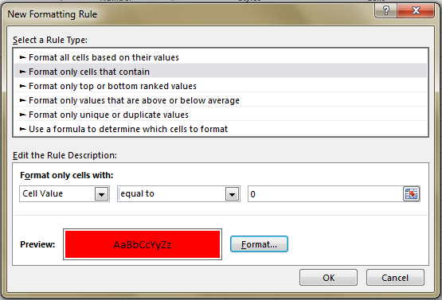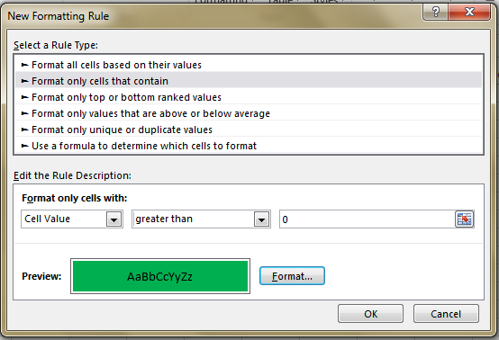

**Google Spreadsheets**

Almost all of the above information (besides graphing) applies to Google Spreadsheets (available through Google Drive). These are a great resource if you are trying to have multiple collaborators on a project. Check out [this link](http://www.google.com/sheets/about/) for more information.

# Reference Pictures

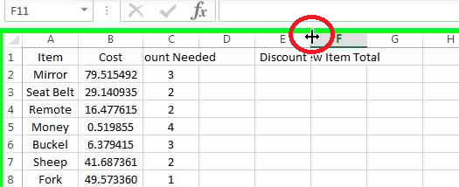

1. Resizing Rows / Columns

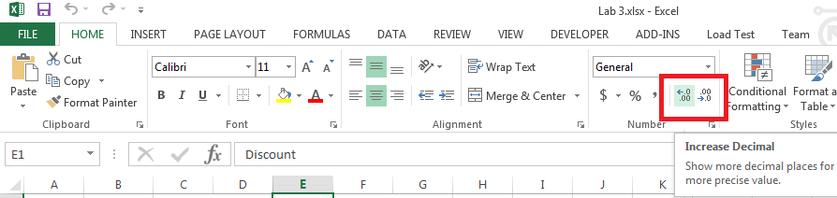

1. Changing Precision

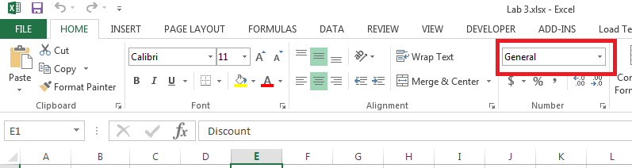

1. Changing Formatting

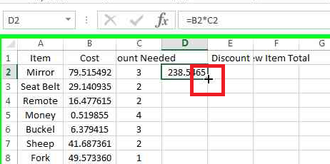

1. Copying a formula

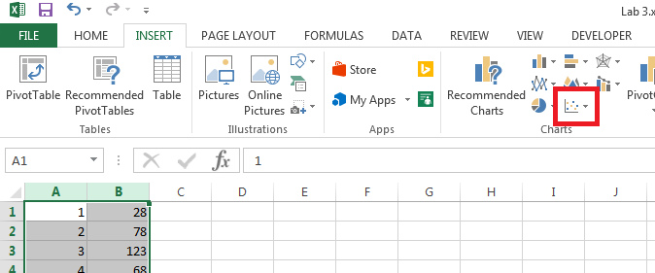

1. Inserting a scatter plot